ORIGINAL Project Title: The Use of Light Sensor
EDITED Project Title: Photoresist Light Sensor
Link: https://wiki.microduino.cc/index.php/The_Use_of_Light_Sensor
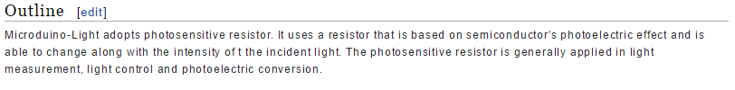
ORIGINAL:
Microduino-Light adopts photosensitive resistor. It uses a resistor that is based on semiconductor's photoelectric effect and is able to change along with the intensity of t the incident light. The photosensitive resistor is generally applied in light measurement, light control and photoelectric conversion.
EDIT:
The Microduino Light Sensor uses a photosensitive resistor to detect the amount of ambient light present. The sensor is effectively a resistor that changes in value as the light intensity surrounding it changes. The sensor will output a voltage value that corresponds to the amount of light detected by the sensor.
Couple the sensor to an LED and you have a smart light that illuminates a room as it gets dark!

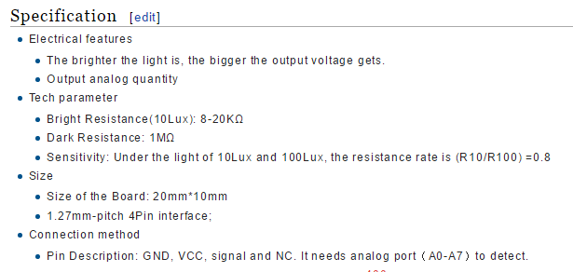
ORIGINAL:
- Electrical features
  - The brighter the light is, the bigger the output voltage gets.
  - Output analog quantity
- Tech parameter
  - Bright Resistance(10Lux): 8-20KΩ
  - Dark Resistance: 1MΩ
  - Sensitivity: Under the light of 10Lux and 100Lux, the resistance rate is (R10/R100) =0.8
- Size
  - Size of the Board: 20mm*10mm
  - 1.27mm-pitch 4Pin interface;
- Connection method
  - Pin Description: GND, VCC, signal and NC. It needs analog port（A0-A7）to detect.

EDIT:
- Electrical Specifications
  - Analog Output Device
  - Analog Output: 0-1023 (with Microduino Core modules)
- Technical Specifications
  - Bright Resistance (up to 100Lux): 8-20kΩ
  - Dark Resistance: 1MΩ
  - Sensitivity:
    - Given light intensity of 10Lux and 100Lux and corresponding resistances of R10 and R100, respectively, the sensitivity factor is 0.8
- Dimensions
  - Board: 20mm x 10mm
  - Interface: 4-Pin, 1.27mm pitch
- Connection Interface
  - Pins: Signal, VCC (power), GND (ground) and NC (not connected).
  - Sensor must be connected to analog capable ports (i.e A0-A7).


ORIGNAL:
- Light-control street lamp

EDIT:
- Couple the Light Sensor with an LED and you can automate the intensity of the LED based on how bright or dark it is in a room.

